Ropes *AB* and *BC* are two of the ropes used to support a tent. The two ropes are attached to a stake at *B*.

If the tension in rope *AB* is 540 N, determine

(*a*) the angle between rope *AB* and the stake,

(*b*) the projection on the stake of the force exerted by rope *AB* at Point *B*.

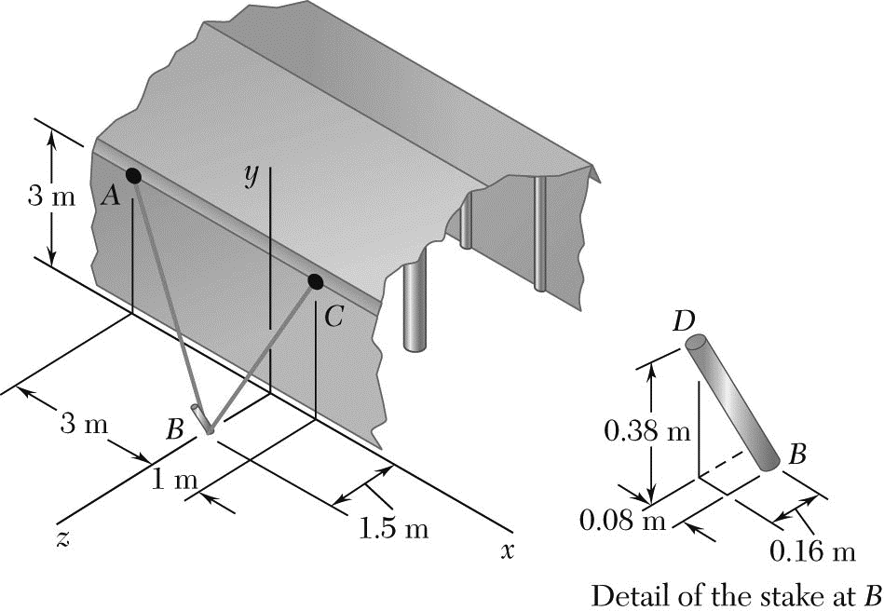

ASSIGNMENT # 2-3 Due on 9/12/19 Student # …………… Name ………………………….

**STATICS** ***UDM ENGR 3120*** - ***BUCT MEC 1701-1703*** ***CHAPTER 3 – Rigid Bodies*** Student Name……………….........